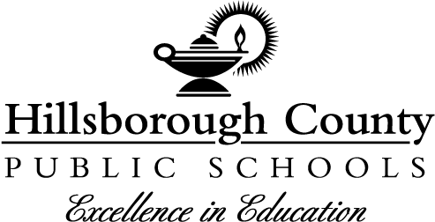

**School Board**

Nadia T. Combs, Chair

Henry “Shake” Washington, Vice Chair

Lynn L. Gray

Stacy A. Hahn, Ph.D.

Karen Perez

Patricia “Patti” Rendon

Jessica Vaughn

# Superintendent of Schools

Van Ayres

**Principal**

**David Parker**

**Assistant Principals**

Lena DiGiovanni

Traci Brown

**Notice to Parents: Right to Know Teacher Qualifications**

To: All Parents

From: Hillsborough County Public Schools

Date: 10/13/2023

As a parent of a student attending a Hillsborough County Public School, you have the right to know the professional qualifications of the teachers or paraprofessionals who instruct your child. Federal law allows you to ask for certain information about your child’s teachers or paraprofessionals and requires us to give you this information in a timely manner if you ask for it. Specifically, you have the right to ask for the following information:

* Whether the Florida Department of Education has licensed or qualified the teacher for the grades and subjects he or she teaches.
* Whether the Florida Department of Education has decided that the teacher can teach in a classroom without being licensed or qualified under state regulations because of circumstances.
* The teacher’s college of major, whether the teacher has any advanced degrees, if so, the subjects and degrees.
* Whether any teachers’ aides or similar paraprofessionals provide services to your child and, if they do, their qualifications.
* The level of achievement of your child on each of the State academic assessments

If you would like to receive any of this information, please contact your child’s school at 813-272-3050. You may call the school between 8:00am-4:00pm, Monday through Friday, and ask to speak to the principal regarding this request. An appointment will be made for you to come to the school to view this information.